**Segment Tree Min-Max**

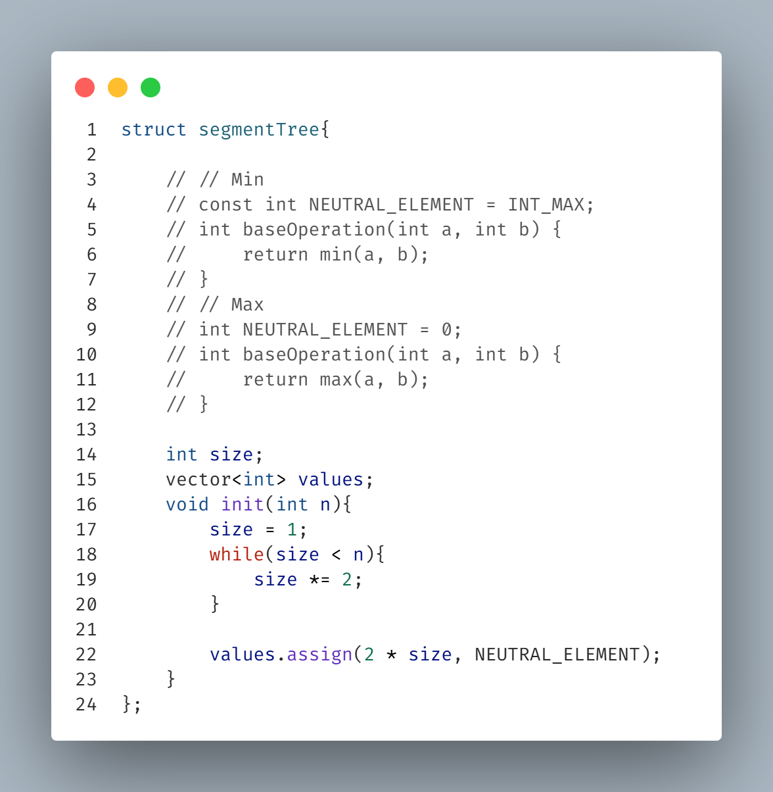**\\ Base code //**

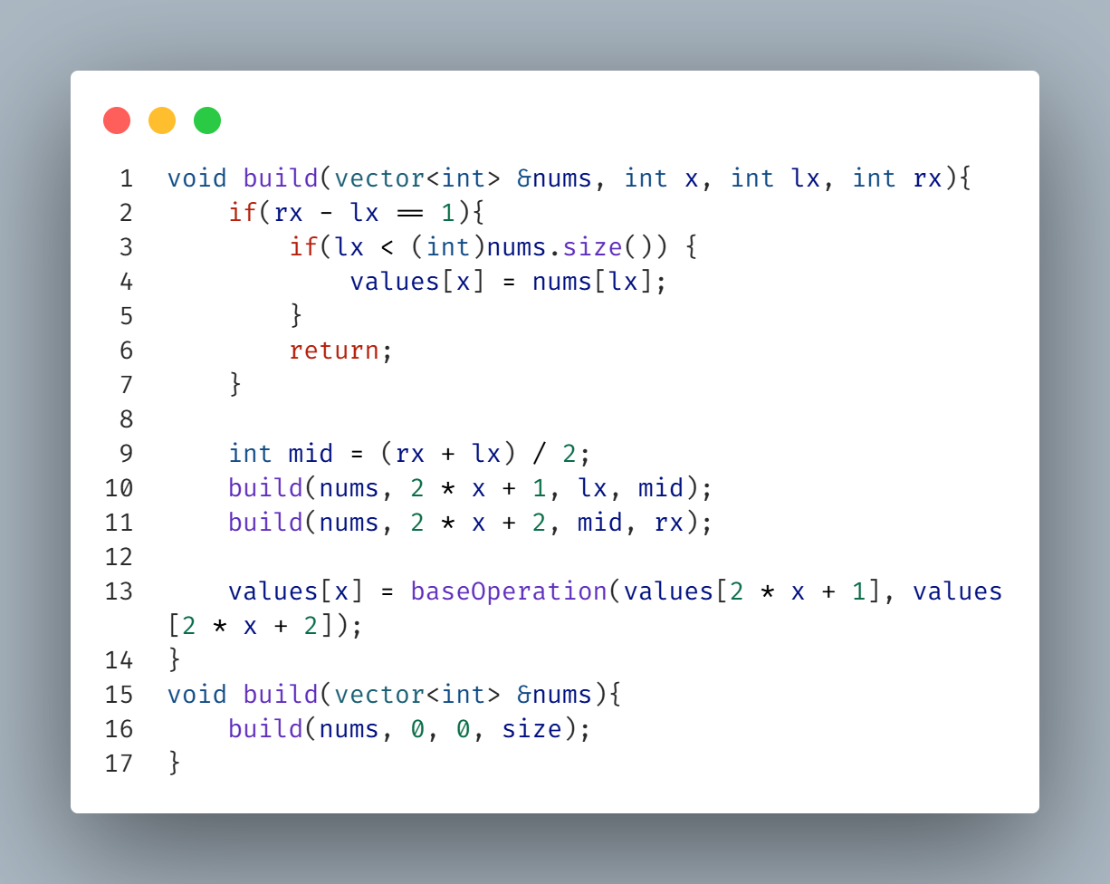**\\ Build Code //**

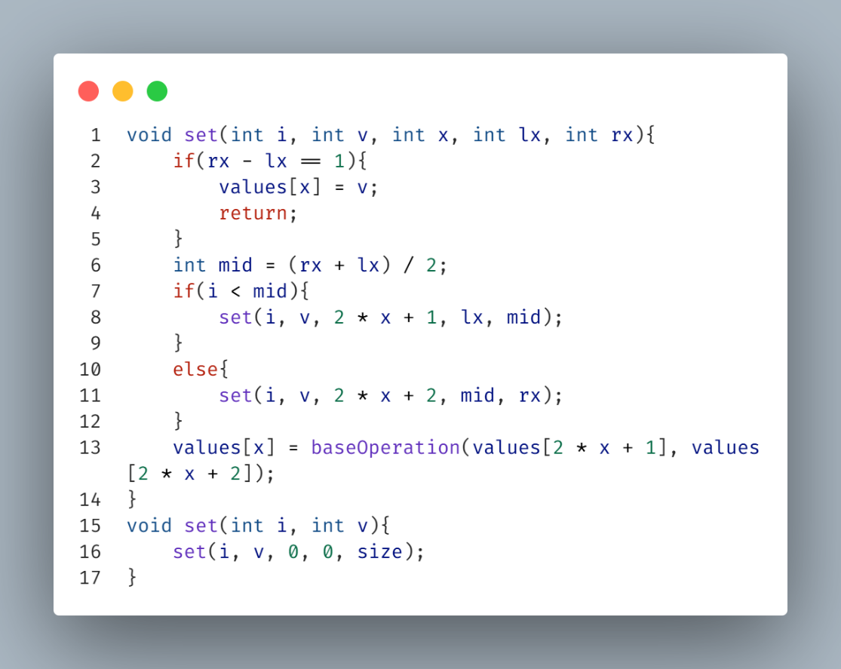**\\ Set Code //**

**\\ Get Code //**

**\\ Set Range Code //**

**Get First Index of an element in range less than a value (v)**

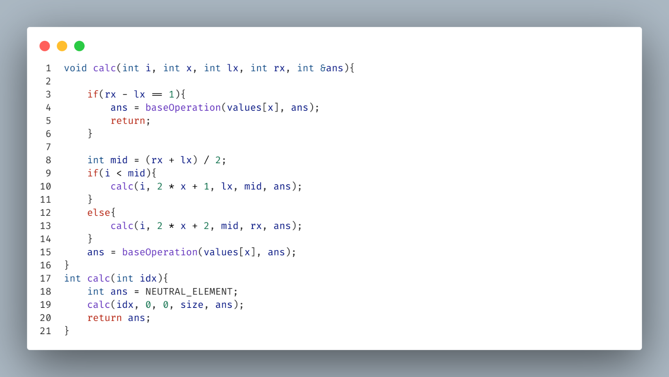**\\ Calc Code [ get value from setRange() ] //**

**Get Last Index of an element in range less than a value (v)**

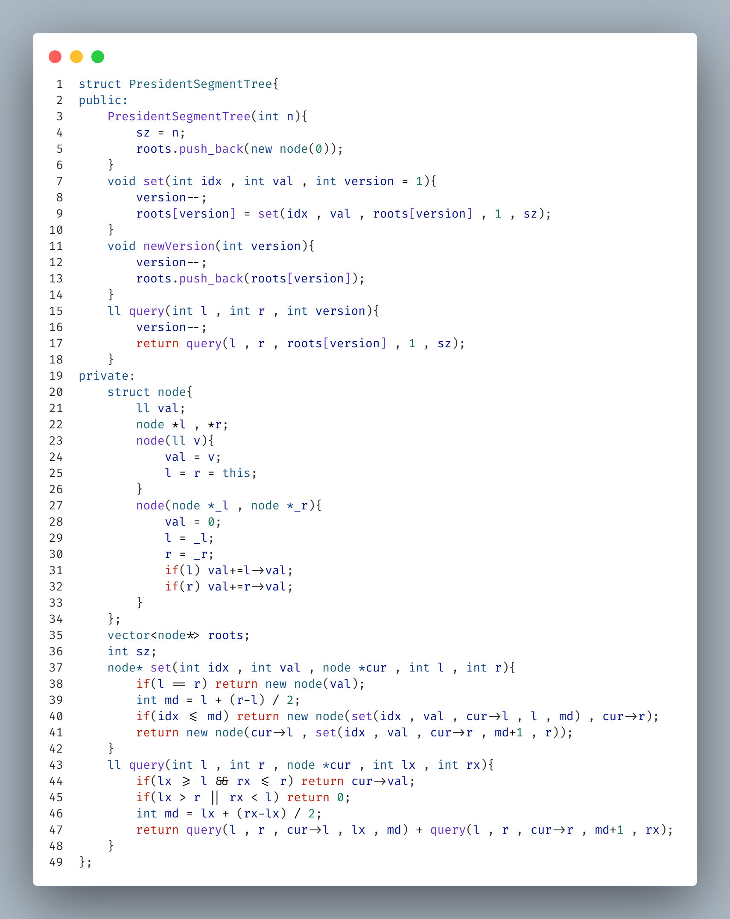**President Segment Tree**

**Ordered Set & Map**

**Kadane**

**Eclidian GCD**

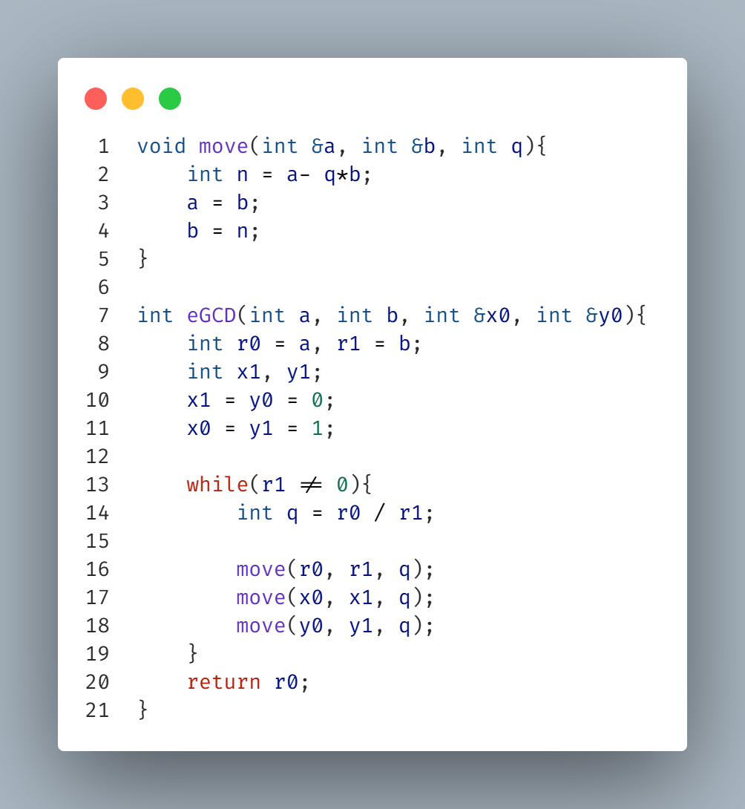

**Factorize**

**Is Prime 1e18**

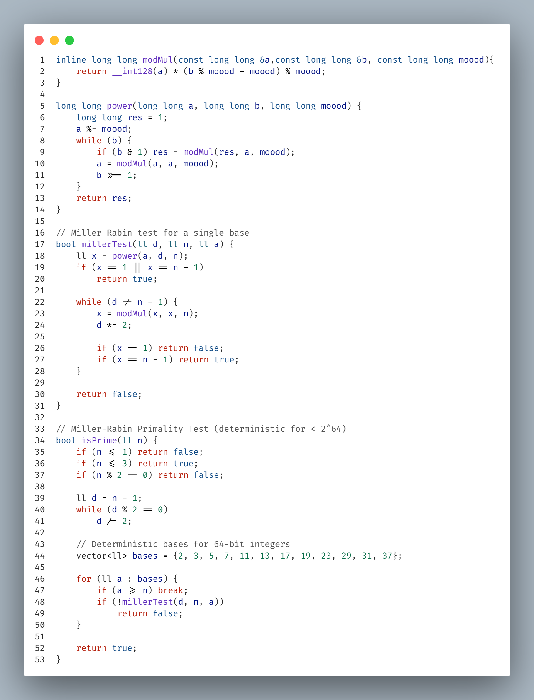**Factorize 1e18**

**\\ Continue //**

**LCA**

**\\ Continue //**

**NUMS**

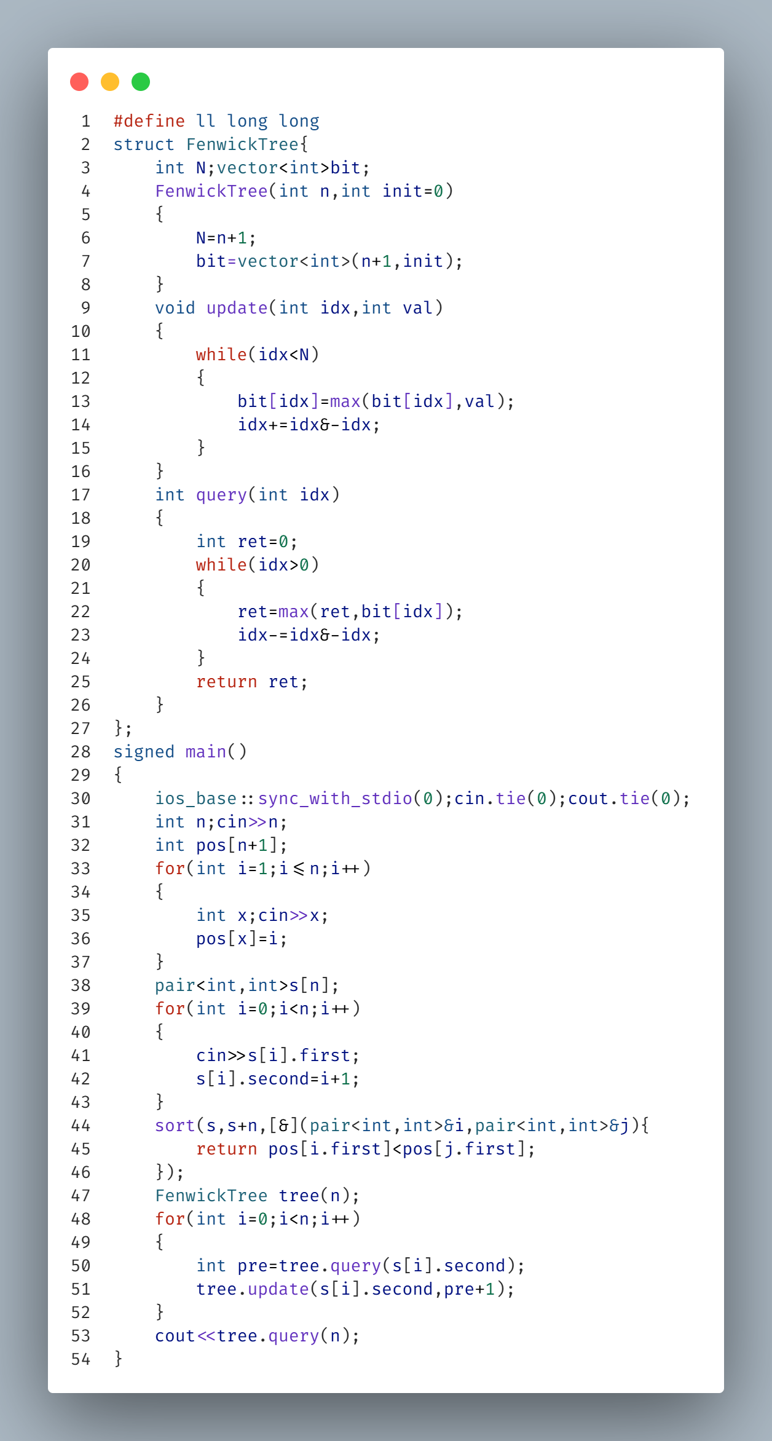**Len. of the longest inc. subseq**

**MST**

**\\ Continue //**

**MEX**